Project Design Phase-II
Data Flow Diagram & User Stories
Date | 31 January 2025 | Team ID | 6ab6179bdcoae83adb386708 (Team 6)
Project Name | Auto Ticket Classification using Flow Designer | Maximum Marks | 4 Marks
Data Flow Diagrams:
A Data Flow Diagram (DFD) is a traditional visual representation of the information flows within a system. A neat and clear DFD can depict the right amount of the system requirement graphically. It shows how data enters and leaves the system, what changes the information, and where data is stored.
DFD Level 0 (Project-specific)
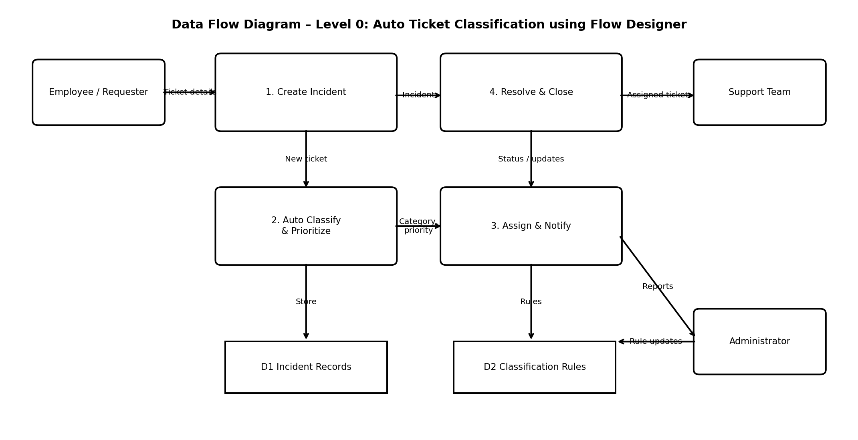
Simplified DFD
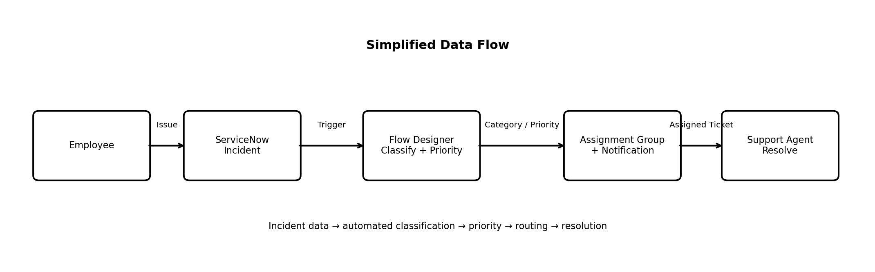
User Stories
Use the below template to list all the user stories for the product.
User Type | Functional Requirement (Epic) | User Story Number | User Story / Task | Acceptance criteria | Priority | Release
Employee (Requester) | Ticket Creation | USN-1 | As an employee, I can create an incident with a short description and detailed issue information. | Incident is created with required fields and a ticket number is generated. | High | Sprint-1
Employee (Requester) | Ticket Creation | USN-2 | As an employee, I can view the status of my submitted incident. | I can see the current ticket status and assigned group. | High | Sprint-1
Employee (Requester) | Notifications | USN-3 | As an employee, I receive a notification when my ticket is created or updated. | Notification contains the ticket number and latest status/update. | Medium | Sprint-2
Flow / System | Auto Classification | USN-4 | As the system, I can classify an incident from its short description and description using predefined rules. | A matching category is assigned automatically; unmatched tickets use a default category. | High | Sprint-1
Flow / System | Priority | USN-5 | As the system, I can set incident priority based on defined conditions. | Priority is populated according to the configured rule conditions. | High | Sprint-1
Flow / System | Assignment & Routing | USN-6 | As the system, I can assign the incident to the appropriate support group. | The incident assignment group matches the classification/routing rule. | High | Sprint-1
Support Agent | Assignment & Routing | USN-7 | As a support agent, I can receive correctly classified and assigned incidents in my group. | Assigned incidents are visible in the group's queue with category and priority. | High | Sprint-1
Support Agent | Resolution | USN-8 | As a support agent, I can update work notes, status and resolution details. | The ticket stores the update and can be moved to the configured resolved/closed state. | High | Sprint-2
Administrator | Monitoring | USN-9 | As an administrator, I can review ticket classification and routing results. | Ticket history shows category, priority, assignment group and flow updates. | Medium | Sprint-2
Administrator | Rule Maintenance | USN-10 | As an administrator, I can update classification rules when new ticket patterns appear. | Updated rules can be saved and used by subsequent incidents. | Medium | Sprint-2

